STAT 441/541 Statistical Methods II

Homework Assignment 1 over Review Material

Submit a single pdf document to the Dropbox folder *Homework Assignment 1 Review Material*.

Start each exercise on a new page.

Note: The scenarios and data are the same as in our text. Some questions have been modified.

Exercise 3.34

The R code file: Exercise 3-34 R Code.R

The dataset is Excel file: ex3-34.xlsx

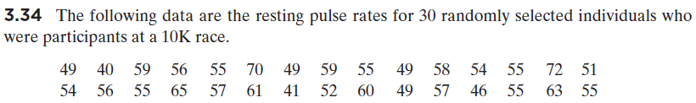

(a) Construct, or paste plot from R output, a histogram of the pulse rates and describe the shape of the distribution of the pulse rates.

(b) Construct, or paste plot from R output, a boxplot of the pulse rates and describe the shape of the distribution of the pulse rates.

(c) The histogram and boxplot provides information about the distribution of pulse rates for what population. That is, what is the population from which we selected our random sample?

Exercise 5.36

The R code file: Exercises 5-36 and 5-37 R Code.R

The dataset is Excel file: ex5-36.xlsx

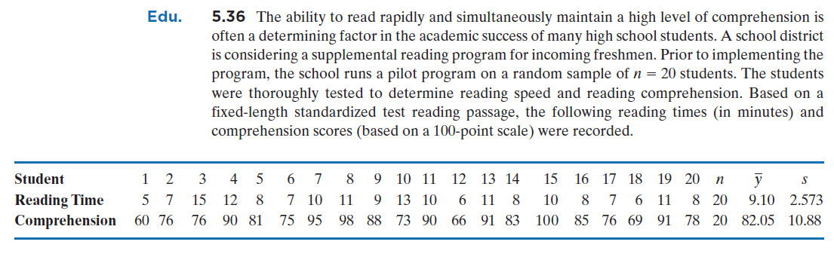

(a) What is the population about which inferences are being made?

(b) Construct, or paste output from R, a 95% confidence interval on the mean reading time for all incoming freshmen in the district.

(c) Provide an interpretation of the interval estimate in part (b).

(d) Construct, or paste plot from R output, a normal probability plot of reading time. Do the data appear to be a random sample from a population having a normal distribution?

Exercise 5.37

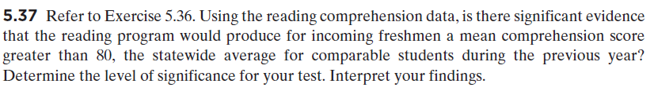

Provide all five parts of the statistical test and use a significance level of .

1. Null and Alternative Hypotheses:

:

:

2. Test Statistic. T.S. =

3. *P*-value =

4. Decision about the null hypothesis:

5. Conclusion: